break statement
The break statement enables a program to skip over a part of the code. A break statement terminates the very loop it lies within.
example
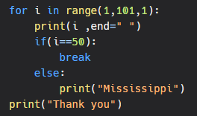
output
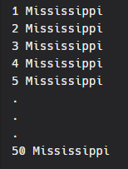
Continue Statement
The continue statement skips the rest of the loop statements and causes the next iteration to occur.
example
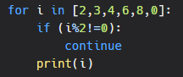
output
